**GOVERNMENT POLYTECHNIC COLLEGE**

**NEYYATTINKARA**



**DEPARTMENT OF ELECTRONICS & COMMUNICATION ENGINEERING**

**VISIT REPORT**

**Community Skills in Indian Knowledge System**

**Course code: 4001**

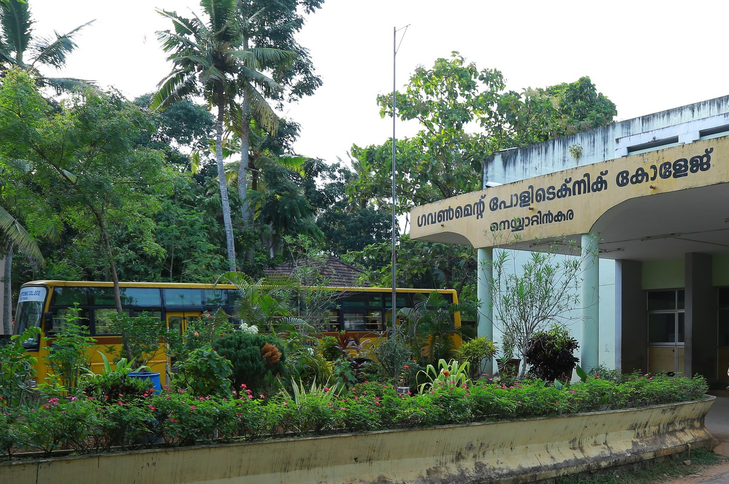

# GOVERNMENT POLYTECHNIC COLLEGE, NEYYATTINKARA

# THIRUVANANTHAPURAM– 83104

**Tel : 0471-2226895, Fax : 0471- 2222935**

**www.gptcnta.ac.in**

[**gptcnta@gmail.com**](mailto:gptcnta@gmail.com)



**INSTITUTION VISION**

To be an Institution moulding Globally Competent Professionals having strong Ethical values to meet the industry and societal needs.

**MISSION**

M1- To inspire, educate and mentor students by facilitating quality engineering and management education.

M2- To promote the entrepreneurial skills and ethical values among the students for the upliftment of society.

**DEPARTMENT VISION**

To develop technically competent socially committed professionals and entrepreneurs in Electronics and Communication Engineering who can address the problems faced by industry and society.

**MISSION**

To provide quality education which enable the students to follow and practice recent technological developments.

To provide learning ambience for developing sense of morality, ethics and social commitment among the students.



**DEPARTMENT OF**

**ELECTRONICS & COMMUNICATION ENGINEERING**

**VISIT REPORT**

**Community Skills in Indian Knowledge System**

**Course code: 4001**

**NAME: ………………………………………………………………………**

**REG. NO: ……………………………………………………………………**

**ROLL NO; ……………………………………………………………………**

**GOVERNMENT POLYTECHNIC COLLEGE**

**NEYYATTINKARA**



**CERTIFICATE**

This is to certify that the visit report of **POTTERY PRODUCTION CENTRE, Thozhukkal, Neyyattinkara**  is prepared and presented by **Name of student (Reg. No: )** towards the partial fulfillment of the subject **Community Skills in Indian Knowledge System** (Subject Code: 4001).

Guided by Head of Department

Internal Examiner External Examiner

**ACKNOWLEDGMENT**

I am deeply indebted to Smt. Name of HOD (department), Government Polytechnic College, Neyyattinkara, who has been the inspiration behind this visit. Her guidance, patience and encourage will be a guiding spirit in all the endeavors of my future.

I would also thank Sri. …….. (Lecturer in ……. Engineering), his guidance and support to develop such a visit report. I take this opportunity to thank all the members of the Department of …………….. Engineering and Library for whole hearted co-operation. I would also like to thank my friends for their support, comments and constructive criticism in the presentation of this report. I also thank the Almighty for the blessings and inspiration that I needed in the bad times.

**Name of student (Reg. No: ……………)**

**ABSTRACT**

About pottery making, traditional skills, traditional knowledge, practices followed in the locality of institution.

**CONTENTS**

|  |  |  |  |
| --- | --- | --- | --- |
| Chapter No | | TITLE | Page No |
|  |  | List of Figures |  |
|  |  | List of Tables |  |
|  |  | List of Abbreviations |  |
| 1 |  | INTRODUCTION TO POTTERY PRODUCTION CENTRE   * 1. Aim of the visit   2. Location map   3. Distance from the Institution   4. Locality details |  |
| 2 |  | HISTORY OF TRADITIONAL POTTERY PRODUCTION |  |
|  | 2.1 | Traditional Knowledge in Pottery Production |  |
|  | 2.2 | Traditional Skills used in Pottery Production |  |
|  | 2.3 | Traditional Practices Followed in Pottery Production |  |
|  | 2.4 | Traditional Process of Pottery Production |  |
|  |  |  |  |
| 3 |  | POTTERY PRODUCTION CENTRE |  |
|  | 3.1 | Establishment details |  |
|  | 3.2 | Products details |  |
|  | 3.3 | Production Floor Layout |  |
|  | 3.4 | Production flow diagram |  |
|  | 3.5 | Work Study  3.5.1. Raw material  3.5.2 Clay grinding unit  3.5.3 Moisture relieving  3.5.4 Pottery wheel & production  3.5.5 Drying  3.5.6 Trimming & cleaning up  3.5.7 Bisque firing/ Choola  3.5.8 Cooling |  |
|  | 3.6    3.7 | Time Study & Production details  Marketing and sales |  |
|  | 3.8 | Advantages |  |
|  | 3.9 | Limitations |  |
|  | 4. | IMPROVEMENTS AND SUGGESTIONS |  |
|  | 4.1 | Productivity enhancement methods & innovative solutions |  |
|  | 4. 2 | Water usage and management methods |  |
|  | 4. 3  4.4 | Waste management methods  Energy management methods |  |
| 5 |  | QUESTIONAIRE |  |
| 6 |  | CONCLUSION |  |
| 7 |  | REFERENCE |  |

**LIST OF FIGURES**

|  |  |  |
| --- | --- | --- |
| Figure No | Title | Page No |

**LIST OF TABLES**

|  |  |  |
| --- | --- | --- |
| Table No | Title | Page No |

**LIST OF ABBREVIATIONS**

|  |  |  |  |
| --- | --- | --- | --- |
| Sl.No | Abbreviations |  | Expansion |
|  |  |  |  |
|  |  |  |  |
|  |  |  |  |
|  |  |  |  |
|  |  |  |  |
|  |  |  |  |